**Project Proposal**

Group Members:

Wensi Xu [xnsxws@gmail.com](mailto:xnsxws@gmail.com)

Yubing Li [yubing-li@uiowa.edu](mailto:yubing-li@uiowa.edu)

Description:

The research was conducted to study CRP, the C Reactive Protein levels of the testing pregnant women when they were giving childbirth. CRP level is a measurement of whether a patient is getting inflammation and infection. After analyzing the relationship between CRP levels and its indicators, we can predict the CRP so as to take early prevention of the diseases and improve maternal and child’s survivals.

The response variable in the datasets is CRP in milligrams per liter. The possible independent variables are age (AGE), pregnant times before (PGT), gestation weeks (GESW), height (HT), weight (WT), difference in weight during the pregnancy (DIFW), baby’s weight (BBW), Preeclampsia and Eclampsia level (PE), urinary protein (UP).

PE is categorical variable (PE=0 if Normal, PE=1 if Mild Preeclampsia, PE=2 if Severe Preeclampsia, PE=3 if Eclampsia). AGE (in years), PGT (in counts), GESW (in weeks), HT (in centimeters), WT (in kilograms), DIFW (in kilograms), BBW (in grams), UP (grams per liter).

Method:

The data were collected from Qin Huangdao Maternal and Child Health Hospital Obstetrics to antenatal examinationc and by Pregnant after 12 weeks in the delivery of pregnant women 1949 cases, who were evaluated from October 2009 to December 2010. 151 simple randomly samples were chosen from the whole population. The data are collected by Haiying Dong from North China Coal Medical University.

Statement:

PE is a special disease during the pregnancy. We assume the CPR will change when a patient has PE.

We assume pregnant women with heavier weights, higher heights, elder ages, more pregnant times are considered to have larger probabilities to catch illness.

Besides, unusual baby weights, unusual gestational periods and larger UP are considered dangerous for giving birth.

In general, they are all potential indicators of CRP levels.

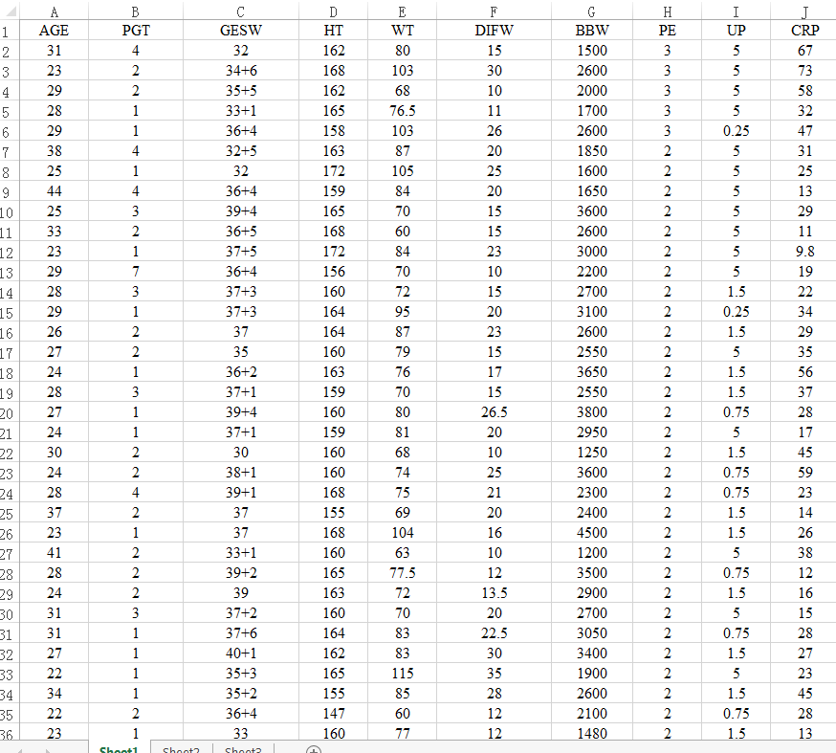Sample of actual data: